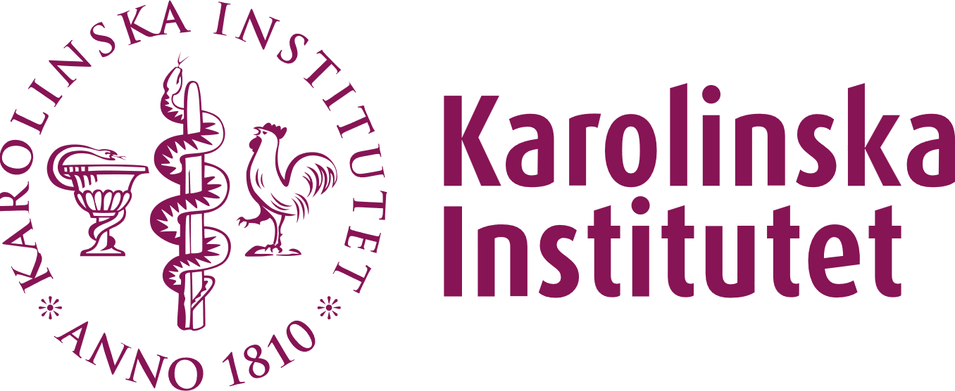

**Assurance form document**

By submitting the Assurance from I am submitting an expression of interest to be a host laboratory for the Mats Sundin Postdoctoral Fellowship in Human Developmental Health in 2025.

Karolinska Institutet and the University of Toronto are announcing the 2nd Mats Sundin postdoctoral fellowship 2 in 2025, by welcoming Principal Investigators (PIs) to submit a project proposal together with a doctoral student graduate or junior postdoctoral fellow from U of T. The highest ranked project at KI will receive a grant of approx. 1.8 million SEK to be distributed to the host department/host laboratory to cover the salary of the incoming postdoc for two years.

This form, electronically signed (EduSign) by the PI and Head of the Department, should be submitted with the application.

**PI: __________________________________**

**Department: ___________________________**

By signing below, we confirm that:

1) The listed PI may participate in the project application with a potential postdoctoral fellow for the Mats Sundin Fellowship in Human Developmental Health.

2) The incoming postdoctoral fellow will be employed for a two-year postdoctoral position at the KI department listed above if the project is awarded funding.

3) The PI will ensure that there is a good working environment and additional funding to cover the project-related and some travel costs*.

4) The PI is aware that submitting this application will result in her/his name being published on the list for University of Toronto trainees distributed in emails and/or on the website.

*1-2 meetings per year